(1) HISTORY OF TOYS: Timeline

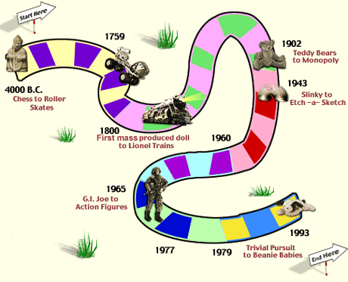

4000 B.C A Babylonian board game is played that was probably an ancestor of chess and checkers.
3000 B.C. First game resembling backgammon is played in Ancient Sumeria. Games similar to backgammon had probably been played by Egyptians, Greeks, and Romans for thousands of years.
Stone marbles are first used in Egypt. Later, glass marbles were popularized in the US in the 1800s.
1000 B.C. Kites appear in China. They have probably been flown since before recorded history.
Stone yo-yos begin to be used in Greece.
200 The first iron skates are used in Scandinavia.
600 An ancestor of chess begins to be played. It evolves from an Indian game called Chaturanga.
969 Playing cards begin to be used in Asia.
1400s Modern chess pieces were finally standardized.
1759 Roller skates
1824 First rubber balloons (ancient people made balloons from animal intestines, and other parts)
1840 Dolls begin to be mass-produced in the US.
1800s Playgrounds begin to appear in US cities.
1843 “The Mansion of Happiness” becomes the first board game sold in the US.
1860s First bicycle
1886 BB gun. The BB gun is a descendant of the cap gun, which was invented soon after the Civil War, when some shotgun manufacturers converted their factories to make toys.
1887 The speaking doll, which had first been invented by Johann Maelzel in 1820, is improved when Thomas Edison combines his phonograph technology with a doll, allowing it to speak.
- battery-powered train
1902 Toy bear craze begins. "Teddy Bears" named after President Theodore Roosevelt.
1903 Crayola crayons
1913 Erector Set
1914 Tinker Toys
1915 Raggedy Ann dolls
1916 Lincoln Logs
1928 Mickey Mouse
1929 The yo-yo is popularized in the US.
1936 Monopoly.
1940s Affordable, plastic model airplanes
1943 "Slinky". If stretched end to end, the Slinky toys sold since 1945 would wrap around the world 126 times.
1949 Legos, Candy Land, Silly Putty
1952 Mr. Potato Head
Pez mint dispenser comes to the US.
Matchbox car.
1956 At a 4th of July BBQ, Milton Levine dreams up the idea for the first Ant Farm, complete with live ants.
Play-doh enters the market as a wallpaper cleaner. Over 700 million pounds of Play-doh have been sold.
1957 Tonka trucks
1958 Skateboards were marketed, but kids had been building them for years on their own.
1959 Barbie doll. Hula Hoops (A similar toy was used as long ago as 1000 B.C. in Egypt, and, later, Greece and Rome)
1960 Etch-a-Sketch, Game of Life
1965 G.I. Joe – doll for boys
1966 Hot Wheels
1969 Nerf ball
1972 Odyssey, the first video game machine
1973 Dungeons & Dragons
1977 Star Wars action figures
1983 Nintendo Entertainment System
1986 Cabbage Patch Kids - becomes the most successful new dolls in the history of the toy industry
Pictionary
1987 Koosh Ball
1993 Beanie Babies – started with a dog, a platypus, a moose, a bear, a dolphin, a frog, a lobster, a whale, and a pig. Not a big success until 1996 when they became a collector's item.

The History Channel, History of Games http://www.history.com/exhibits/toys/index.html

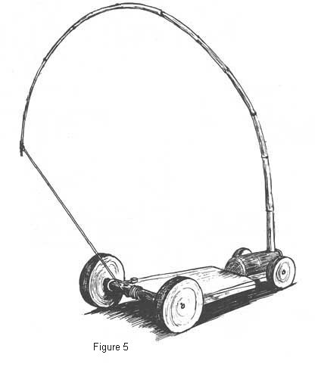
(2) SELF-PROPELLED CARS

Cable Car

Tension on the cable pulls
The string, which turn the rear axle.

Spool car
Need a wooden spool.
Pin a rubber band on one end (can use short stick and a tack).
On the other end, pass band through a piece of wax. Insert pencil or stick. Wind up band and let
can go. Potential energy in converted to kinetic energy.
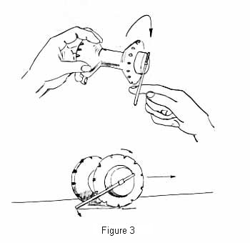

(3) List toys your Grandma and Grandpa may have played with:

1.

2.

3.

4.

5.

6.

7.

8.

9.

10.

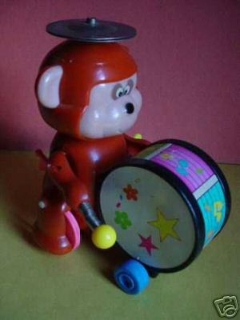
Homemade dolls – yarn dolls
Mechanical toys – wind up Jack-in-the-box
Puppets; Slingshots
Hula hoops
Bicycle
Roller skates with 4 wheels each, may have tied them to
their shoes (not inline skates)
Kites (may have been homemade)
Homemade boats
Plastic models
Cars and trucks that had to be pushed (no motors)
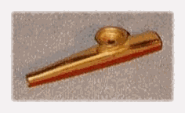
Rocking horse
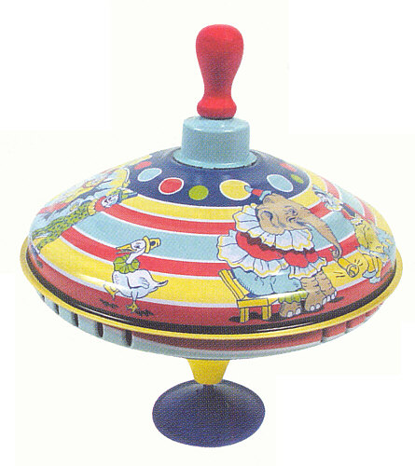
Pop guns
Wooden train set
Stacking dolls (Russian)
Blocks
Cup & ball game
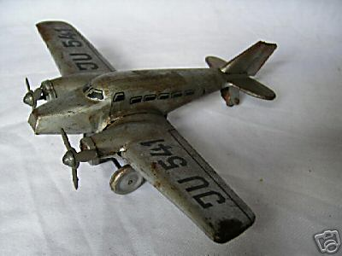
Bean bag toss
Spinning tops
Toy drum, harmonica, kazoo
Tea set
Knitting, embroidery
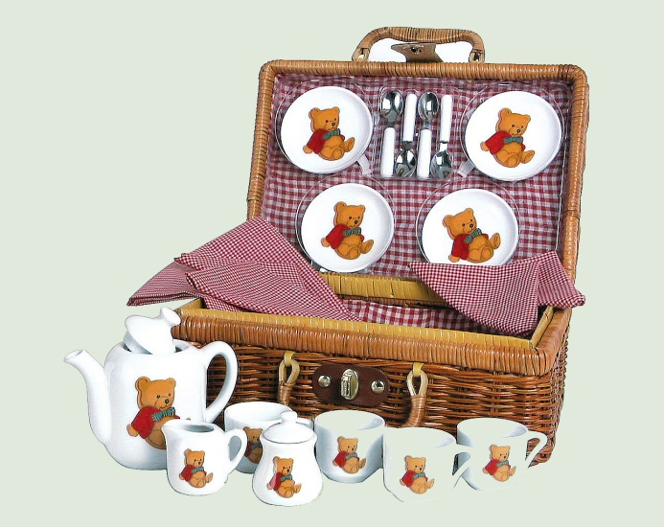
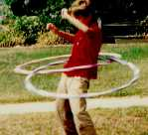
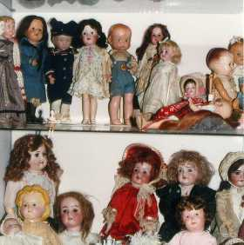
(4) AGE APPROPRIATE TOYS
Some toys have small pieces. Some toys have moving parts or removable parts. Some require you to be able to read or react very quickly. Describe toys and games appropriate for the following age groups:
0-1 years:
1-3 years:

3-6 years:

6-9 years:

8-adult:

(5) MAKE A TOY FROM TRASH:
Suggestions -
- Make a sock puppet from an old clean sock, scrap yarn, old buttons. Stitch on a face (could use buttons as eyes). Tie long yarn pieces on for hair.
- Make a cup catcher toy from an empty single-serving yoghurt container, a large nut (buckeye) or similar item, and a piece of string. With an adult assistant, drill a hole through the buckeye and tie an18-20inch string through it. Punch a small hole through the bottom of the yoghurt container. Insert the string and either tie a large knot or tie a button onto this end of the string so that it won’t pass back through the hole. Hold the cup in one hand, swing nut up and try to catch it.

(6) DESIGN A ONE PERSON GAME that requires some mental muscle to complete. Suggestions include:
  - word search
  - crossword
  - math code game
  - sudoko

(7) DESIGN YOUR OWN BOARD GAME
Examine (and play) several different board games. Try ones that use dice and ones that don’t. Try games that rely on different things to win (luck, strategy, and knowledge).
Look at games that are intended for different age groups (Candyland, Trouble, Scrabble).
Now design a board game that would be fun for you and your friends to play. Bring it to the next meeting so we can try it out.

